**APPLICATIONS OF BLOCKCHAIN FOR SECURE**  **BANK TRANSACTIONS**

**Shivam Patil *1, Pratik Aher*2, Prathmesh Phadtre*3, Gaurang Mhatre*4**

*1,2,3,4 Department of Artificial Intelligence and Data Science Engineering, Zeal College of Engineering and Research, Pune, Maharashtra, India

(Prof. Anuja Garande, Department of Artificial Intelligence and Data Science Engineering, Zeal College of Engineering and Research, Pune, Maharashtra, India)

**ABSTRACT**

Blockchain technology represents a contemporary approach that enhances the ease and security of financial transactions between parties. Given the prevalent targeting of the financial industry by fraudulent activities, the primary goal is to streamline transactions by removing associated obstacles. This is achieved by allowing teams to automate network traversal, focusing solely on a singular point, namely the serving computer.

To mitigate the risk of server hacks, the infrastructure supporting database servers is eliminated, with data distribution facilitated through blockchain technology. Establishing a legitimate blockchain involves leveraging the SHA256 algorithm to generate a unique 256-bit hash value, alongside the proof of work consensus mechanism. It's evident that blockchain, particularly through Bitcoin, has already made and will continue to make a significant impact on the world in forthcoming years.

This assertion holds weight, especially considering the relentless efforts of numerous individuals striving to address the various limitations hindering blockchain's mainstream adoption. One notable drawback is the substantial processing and electricity expenses associated with the Proof-of-Work consensus system, which directly stem from the protocol.

Proof-of-Work consensus system incurs substantial processing and electricity expenses. These costs are a direct result of the protocol.

**Key Words:** Wallet, Public/Private key, Consensus algorithm, SHA256, Proof of Work

.

**1. INTRODUCTION**

In recent years, the term "blockchain" has gained significant traction, reflecting its profound impact across various sectors. It's widely expected that blockchain technology will revolutionize business operations, not only within banking but also in sectors like healthcare, government, and retail. In recent years, the term "blockchain" has gained significant traction, reflecting its profound impact across various sectors. It's widely expected that blockchain technology will revolutionize business operations, not only within banking but also in sectors like healthcare, government, and retail. Essentially, a blockchain functions as a distributed ledger or public database shared among multiple users, ensuring an immutable record of transactions through cryptographic protection.

The banking industry stands to reap substantial benefits from blockchain implementation, offering increased openness, efficiency, security, and cost-effectiveness. Here are several ways in which blockchain technology will shape the future of the financial system:

**1.By Expediting International Transfers**

Blockchain, with its distributed ledger technology, has the potential to streamline monetary transactions domestically and internationally. Currently, the process of transferring funds across borders can be slow, costly, and opaque, involving multiple intermediaries. Such intermediaries take a share of the transaction proceeds, leading to significant financial losses for the sender by the time the funds reach their destination.

Blockchain facilitates peer-to-peer transactions, making them faster, more transparent, and cost-effective for both international businesses and consumers. For instance, individuals using Bitcoin wallets can conduct transactions swiftly. Additionally, multinational enterprises benefit from the transparency and efficiency offered by blockchain.

In essence, a blockchain serves as an immutable digital ledger recording financial transactions between parties. Each transaction undergoes verification by network computers before being added to the blockchain. Once recorded, transactions cannot be altered or tampered with, ensuring the integrity and security of the financial system.

1. **By Increasing Security & Reducing Fraud**

Blockchain technology contributes to enhancing security and combating financial fraud by establishing a transparent audit trail. Its inherent redundancies make altering posted information extremely challenging, if not impossible, once it's on the network.

Maintained by hundreds of computers, the blockchain network lacks a single point vulnerable to hackers, making it difficult for them to alter data without leaving traces. This aspect of blockchain is particularly crucial in the current landscape of rampant cybercrime and widespread ransomware attacks, which jeopardize critical information and result in substantial financial losses for victims.

It's important to complement blockchain security measures with additional precautions, such as securing Windows systems and using a virtual private network (VPN) for added security. Additionally, referring to a ransomware checklist ensures readiness with an appropriate cybersecurity plan in case of a cyberattack.

1. **By Reducing Costs for Banks and Customers**

Blockchain technology holds promise for significantly reducing costs for both banks and customers, while simultaneously enhancing the quality of banking services.

Financial institutions are actively exploring ways to leverage blockchain technology to address issues related to inefficiency and high costs. By adopting blockchain, certain banking operations can be automated, leading to streamlined processes and reduced expenses.

The decentralized nature of blockchain, coupled with its inherent security, openness, and simplicity of installation, makes it an ideal candidate for enhancing banking operations. Its transparency further facilitates automation of tasks such as payments and loan issuance.  
Users can transfer funds peer-to-peer without intermediaries using electronic cash. Ethereum blockchain integration into equivalent networks expands its utility. Digital signatures and organizations with digital certificates enhance and challenge centralized structures [3].

**4. By Reducing Human Error**Various reports highlight that human errors in accounting, record-keeping, and reconciliation are among the primary causes of fraudulent activities. In security operations, negligence or inadvertent mistakes by individuals often lead to significant cybersecurity issues.

Transactions recorded on a blockchain utilize an automated mechanism that prevents subsequent alterations. Implementing this technology will significantly reduce the need for manual tasks, thereby minimizing errors caused by human involvement, enhancing productivity, and mitigating the impact of cyberattacks.

Distributed ledger technology offers enhanced personal data protection compared to centralized storage. Compromising the entire blockchain network necessitates access to 51% of it, rendering this task unfeasible. Operational nodes within the open blockchain's distributed ledger network contain encrypted tokens containing intelligence string data, facilitating cryptocurrency development, transmission, and storage [4].  
  
  
**2. LITERATURE REVIEW**The allure of blockchain technology stems partly from its decentralized nature and the ability to operate anonymously. Within a peer-to-peer network, transaction histories of most nodes are stored, preventing "double spending." Proof of work (POW) serves as a consensus mechanism to maintain integrity [1].  
  
Various implementations of POW on blockchain represent different forms of consensus. This mechanism involves multiple parties determining whether a transaction can be added to the corresponding blockchain, with cryptographic puzzles becoming increasingly challenging to solve [2].  
Proof of work for cryptocurrencies requires validation by every network node. Keeping primes, such as record breakers, reasonable is vital. Mersenne primes are no longer feasible, necessitating the main chain's use for primary coin operations due to the exponentially challenging task of discovering the primary chain [6].

**3. PROPOSED METHODOLOGY**The concept of "blockchain technology" encompasses various forms of online digital asset trading. In this context, the technology is utilized to enhance the security of banking transactions. Thanks to its distributed and decentralized ledger, blockchain simplifies transaction validation and prevents any unauthorized updates to the ledger. This technology enables a wide range of transactions to be conducted securely.

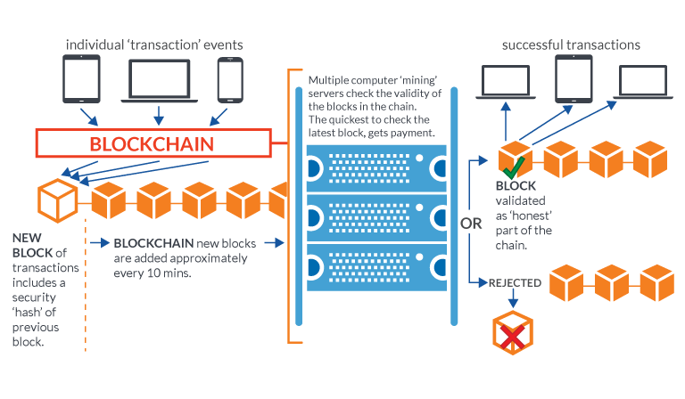  
  
Figure 1. Transaction in blockchain

**3.1 BLOCK CHAIN**Blockchain technology presents the opportunity to share a storage device among all participants within a business network. This shared ledger ensures consensus, provenance, immutability, and intent regarding the introduction of assets into the network. Consequently, this leads to a streamlined process and reduced time requirements. Each block in Figure 2. contains a hash of the preceding block.

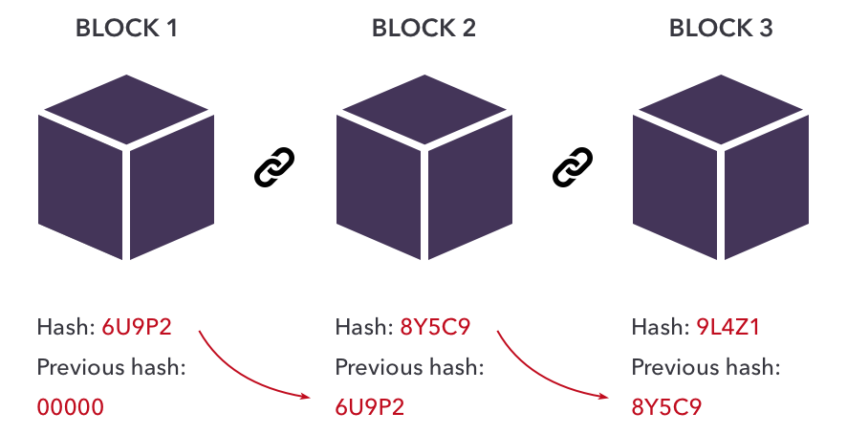

Figure 2.Blockchain

**3.2 ALGORITHM  
  
A. Proof of Work:**

A stake is value/money we bet on a certain outcome. The process is called staking.

A more particular meaning of stake will be defined later on.

**Why Proof-of-Stake:**

Before proof of stake, the most popular way to achieve distributed consensus was through Proof-of-Work (implemented in Bitcoin). But Proof-of-Work is quite energy(electrical energy in mining a bitcoin) intensive. So, a proof-of-work based consensus mechanism increases an entity’s chances of mining a new block if it has more computation resources. Apart from the upper two points, there are other weaknesses of a PoW based consensus mechanism which we will discuss later on. In such a scenario, a Proof-of-Stake based mechanism holds merit.

**What is Proof-of-Stake:**

As understandable from the name, nodes on a network stake an amount of cryptocurrency to become candidates to validate the new block and earn the fee from it. Then, an algorithm chooses from the pool of candidates the node which will validate the new block. This selection algorithm combines the quantity of stake (amount of cryptocurrency) with other factors (like coin-age based selection, randomization process) to make the selection fair to everyone on the network.

**Working:**

POW authenticates transactions, leading to the addition of new blocks to the ledger once transactions are confirmed. Each successfully processed transaction results in the addition of a new block to the blockchain ledger, requiring significant computational power.

**B. SHA256**SHA256 is a cryptographic hash function utilized within blockchain technology. It generates a unique fingerprint-like hash for data, ensuring data integrity and security. The SHA256 algorithm produces a 256-bit hash value that is fast, unique, and ideal for applications requiring data protection, encryption, digital signatures, and blockchain security measures.  
  
**Peer to Peer Networks to Node**In Module 2, we established a single node/server. Now, our focus shifts to creating 2 or 3 nodes to establish a Peer-to-Peer (P2P) network. Each node will uphold its own copy of the Blockchain, and a web miner will ensure the integrity across the network. In this setup, we'll employ the Proof-of-Authority (PoA) consensus algorithm, suitable for permissioned ledgers. PoA relies on a group of 'authorities,' designated nodes authorized to generate new blocks and secure the ledger. To create a block, a consensus among the majority of these authorities is necessary. Block Storage, essentially, refers to the ledger and database used for storing blockchain details. **4. SOFTWARE DESIGN**

A data flow diagram (DFD) serves as a visual representation illustrating the flow of data within an information system, capturing its procedural aspects. Typically, a DFD acts as an initial step to provide an overview of the system's functionality without delving into intricate details, which can be further refined later on. At the pinnacle of DFDs lies the context diagram, also referred to as "Level 0." This diagram comprises a single process node, denoted as "Process 0," encapsulating the overall function of the system in relation to external entities. The construction of DFDs involves layering, with the context diagram being the foundational level, followed by subsequent layers detailing various aspects of data flow within the system**.**

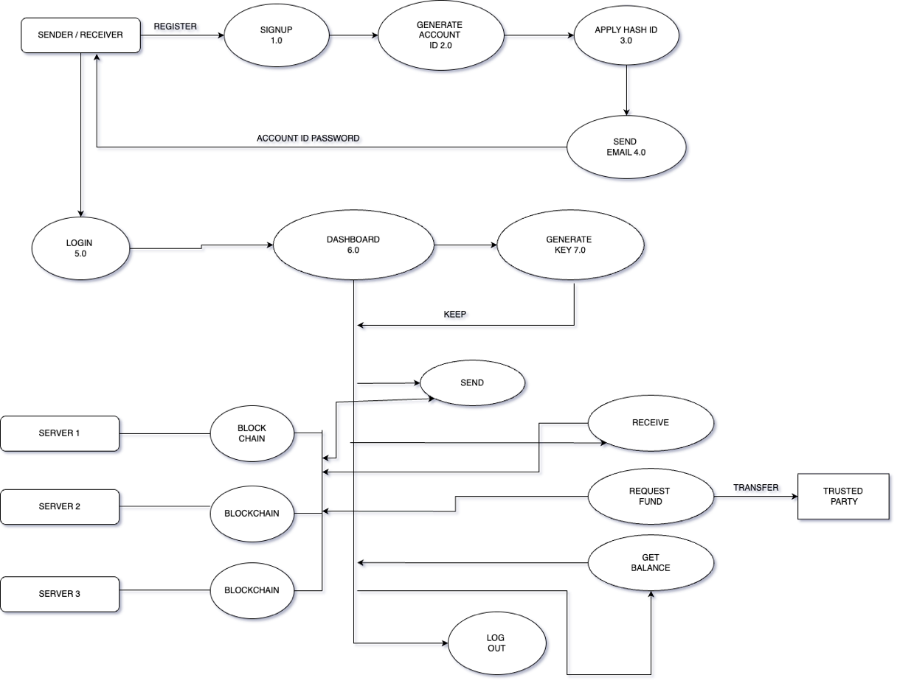

Fig.Level 1 DFD  
  
  
  
  
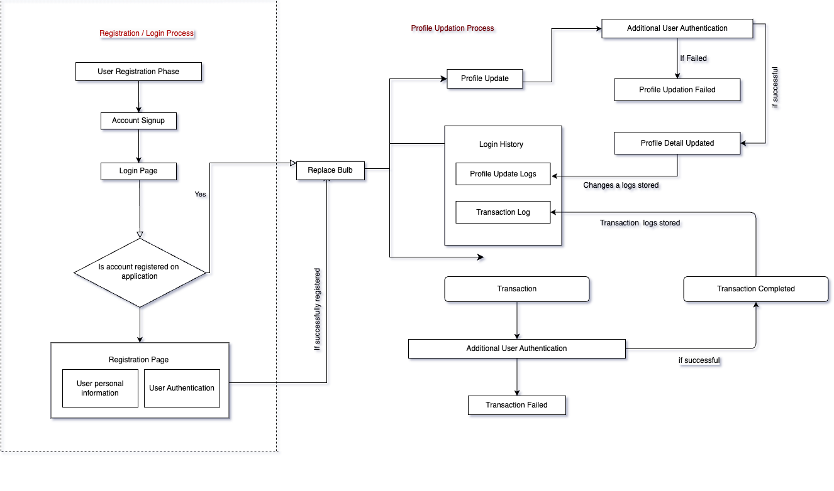

Fig. 4.1: Software Architectural design

**5. THE POTENTIAL OF BLOCKCHAIN TECHNOLOGY IN THE BANKING SECTOR**

In the banking sector, where a high volume of transactions occurs daily, Blockchain technology holds immense promise in enhancing security and authenticity. Embracing the concept of a trust economy, Blockchain offers financial institutions an opportunity to cultivate trust and confidence among their customers. This technological advancement stands poised to revolutionize the financial services offered by banks, given the vast scale of the global financial system, which serves billions of individuals and businesses, with trillions of dollars in circulation each day.

**A) Advantages of Blockchain:**

* Accelerating transaction speed: Blockchain's verification system holds the potential to facilitate near-real-time processing and settlement of transactions.
* Reducing costs and complexity: Blockchain can streamline and automate interactions with external parties, as well as internal processes, thereby cutting costs and simplifying operations.
* Minimizing data duplication: By providing a single shared view of truth within the network, Blockchain diminishes data entry duplication and the need for reconciliation.
* Enhancing resilience: The distributed nature of Blockchain eliminates a single point of failure, making it considerably more resilient than current systems.

**B) Current System:**

Traditional systems are typically burdensome, prone to errors, and frustratingly slow. They often require intermediaries to mediate processes and resolve conflicts, resulting in stress, time, and financial expenses. In contrast, Blockchain offers users a cheaper, more transparent, and more efficient alternative.

**6. FUTURE PROSPECTS**

* While our immediate focus lies in implementing a blockchain system for online banking transactions, its applicability extends across various domains with slight adaptations:
* Authentication and Personal Identification: Blockchain technology can revolutionize the way passwords and personal identification are managed, offering enhanced security and reliability.
* Healthcare: Implementing blockchain in healthcare can streamline medical records management, ensure data integrity, and facilitate secure sharing of patient information among healthcare providers.
* Government Services: Blockchain has the potential to improve transparency, efficiency, and trustworthiness in government services, such as identity management, voting systems, and public recordkeeping.
* Internet of Things (IoT): By leveraging blockchain, IoT devices can securely communicate and transact with each other, enabling new possibilities for automation, data integrity, and decentralized control.
* Financial Services: Beyond online banking, blockchain can transform various aspects of financial services, including insurance, supply chain finance, and asset management, by enhancing transparency, security, and efficiency.

**CONCLUSIONS**The consensus algorithms widely accepted as industry standards within blockchain technology remain a topic of ongoing debate. The immutability and transparency inherent in blockchain systems are often cited as additional advantages.

Maintaining a decentralized public ledger, free from direct control or regulation, presents significant hurdles to overcome. However, solutions such as private distributed ledgers and blockchains can be developed to address such challenges.

The immense computational power required makes it exceedingly difficult for any individual to compromise the system.

Transactions can be executed more efficiently using blockchain technology, as it eliminates many of the steps involved in traditional transactions. Here, we employ blockchain technology to ensure secure banking transactions.

**REFERENCES**

1. [[Blockchain application and outlook in the banking industry, Ye Guo and Chen Liang, 2016](https://www.researchgate.net/publication/311549710_Blockchain_application_and_outlook_in_the_banking_industry)
2. [Blockchain Technology and the Financial Services Market, Krause et al., 2017](https://www.researchgate.net/publication/307599627_Blockchain_Technology_and_the_Financial_Services_Market_State-of-the-Art_Analysis)
3. [BlockChain & Financial Inclusion,Prof. Reena Aggrawal, 2017](https://digitalchamber.org/assets/blockchain-and-financial-inclusion.pdf)
4. [Blockchain in banking, Deloitte, 2017](https://www2.deloitte.com/content/dam/Deloitte/in/Documents/strategy/in-strategy-innovation-blockchain-in-banking-noexp.pdf)
5. [Block Chain Technology its use in Banking Sector-S Ravi - BW Businessworld](https://www.businessworld.in/article/Block-Chain-Technology-its-use-in-Banking-Sector/26-10-2020-335662/)